ENAC

IATSED PROJECT SELESTER 8

Code rules

## Tools

**IDE** : IntelliJ IDEA

**SDK** : Java JDK 1.8

**Plugin(s)** : …

## Points to Follow

Additionally to the basic rules proposed by IntelliJ, a set of rules must be followed by the whole team to create a homogeneity in the project:

### Code style issues:

* size() == 0 can be replaced with ‘isEmpty()’
* Unnecessary ‘this’ qualifier
* Unnecessary qualifier for ‘this’ or ‘super’

### Naming conventions:

* Local variable naming convention: camelCase

### Class metrics:

* Overly complex class: The cyclomatic complexity total of a class must not be superior than 80
* Overly coupled class: The coupling limit total of a class must not be superior than 15

## IntelliJ XML File

To respect those rules, a pre-defined XML file is proposed. This file can be found in /project_root/Documentations/Project_Default.xml. This is a set of rules that can import into IntelliJ, allowing the appearance of warnings when the code do not respect the rules to be applied.

To import this file, enter **CTRL + ALT + S**.

Then, click on the gear next to “Profile: Project Default” at the top. Then, click on “Import Profile”.

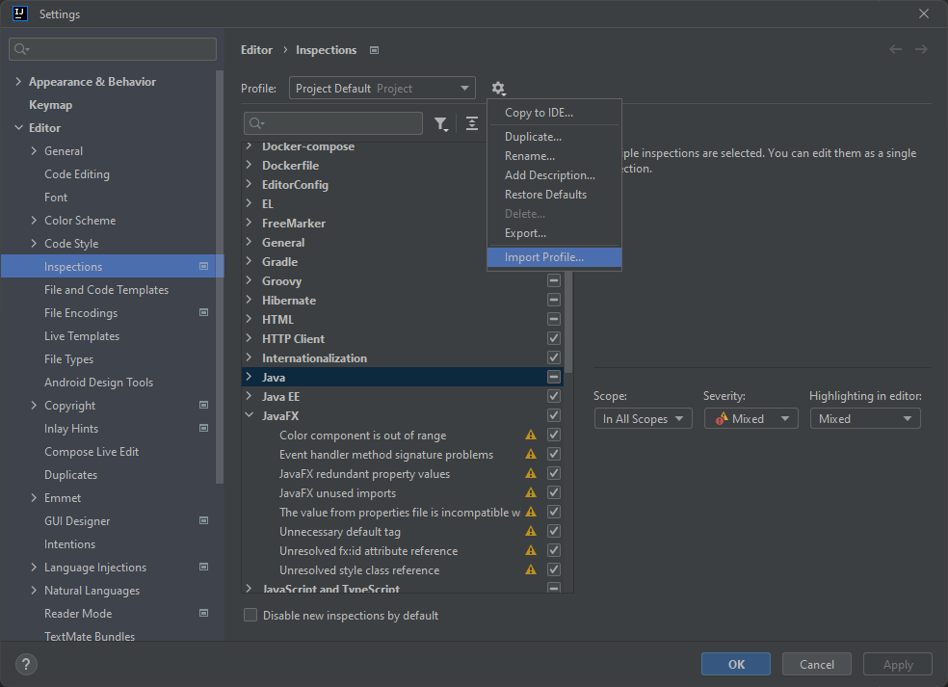

Find the Project_Default.xml file proposed in /project_ root/Documentations. Click on “Apply”.